Caitlan Nichols  
21 June 2024

Module 5.2 - MySQL Functions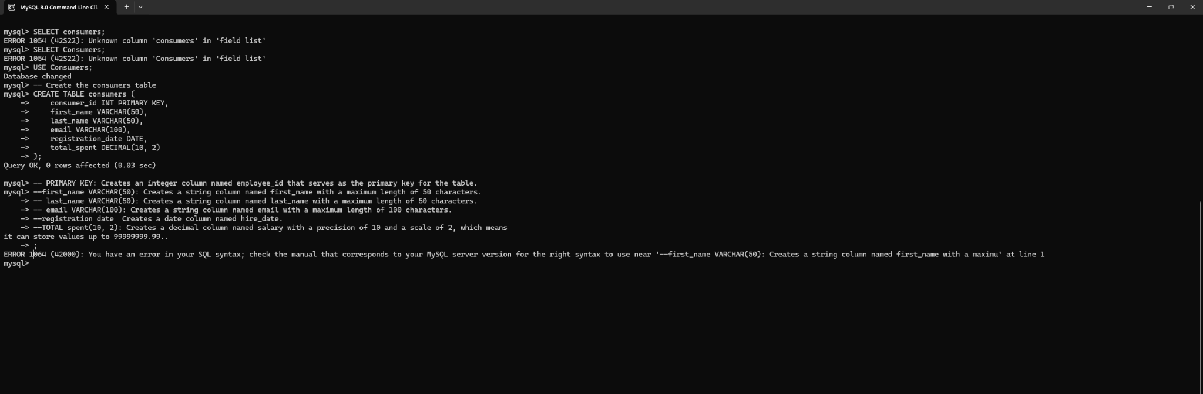

* Comments (--) can be used when creating things to ensure it does not execute as part of the main program which can cause a major issue in coding and can also help guide other developers picking up where you left off. (I, unfortunately, accidentally executed it by putting a few errors in the comment. I meant to explain each part of my table and alias for it).
* The integers placed in parentheses is the amount of characters that can be use

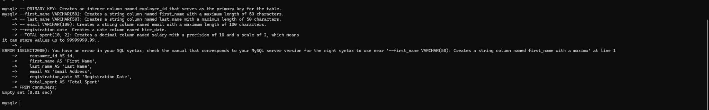

* Using aliases in your SQL queries can make your result sets more readable and meaningful, especially when dealing with complex queries or when presenting data to end users.

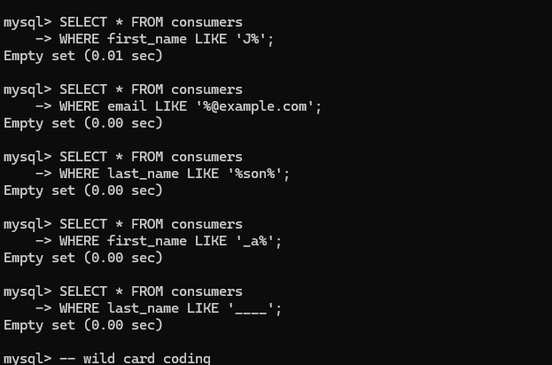

* Using wildcard characters with the LIKE operator allows for flexible pattern matching and can be very powerful for querying text-based data. I can imagine this to be helpful for consumer raffles.